USER INTERFACE DESIGN (CS23A34)
NAME:THIRUMALA SRI.P
ROLL NO:240701569
DEPT:CSE
EXPERIMENT NO:01

  - BAD DESIGN:TO DO LIST
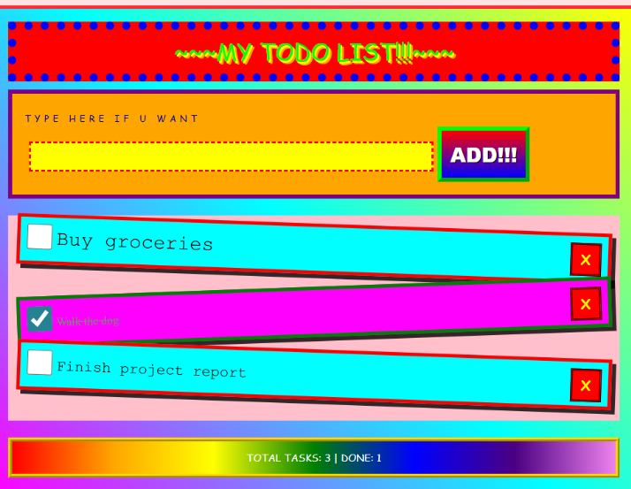
• Color overload
- Too many bright, clashing colors → eye fatigue.
- No visual hierarchy; everything screams for attention.
• Poor typography
- Mixed fonts, caps lock, decorative styles.
- Hard to scan quickly → bad for a productivity app.
• Unclear primary action
- “ADD!!!” button is loud but not clear.
- Over-styled button reduces seriousness and trust.
• Inconsistent alignment
- Task cards are tilted and misaligned.
- Breaks visual flow → looks chaotic.
• Bad affordance
- Checkboxes and delete icons don’t look standard.
- User has to think instead of acting.
• Low readability
- Text on bright backgrounds = poor contrast.
- Accessibility nightmare.
• No spacing discipline
- Elements are cramped in some areas, oversized in others.
- No breathing room → cognitive overload.
• Emotion over function
- Design focuses on decoration, not usability.
- Looks like a poster, not a tool.

  - GOOD DESIGN :TO DO LIST
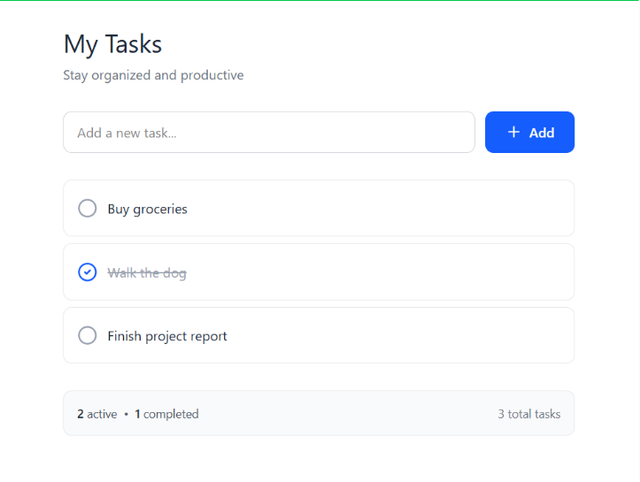
- Clear visual hierarchy
  - Title → input → tasks → summary.
  - User knows where to look instantly.
- Minimal color palette
  - Limited, calm colors.
  - Color used only to convey meaning (active, completed).
- Readable typography
  - Simple font, consistent size.
  - Easy to scan tasks quickly.
- Strong affordance
  - Checkbox looks clickable.
  - Button clearly looks like a button.
- Proper spacing & alignment
  - Equal margins, padding, consistent card layout.
  - Feels organized and professional.
- Task status clarity
  - Completed task visually distinct (strike-through + icon).
  - No confusion.
- Focused interaction
  - One clear primary action: add task.
  - No distractions.
- Scalable design
  - Can handle 3 tasks or 30 without breaking.
  - Suitable for real-world use.

